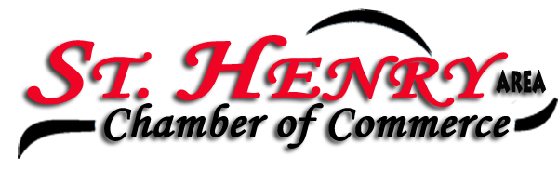

Place: Romer’s Catering, Banquet Room
Date: 1/6/2020

Members present: Leah Koesters, Renee Whittington, Carol Bruns, Andrew Schmitmeyer, Karen Romer, Josh Schmackers, Kim Baumer, Sharon Rindler, Eydie Kremer, John Yoder, Michelle Dues, Kelley Baker. Special Guest, Elizabeth Rockwell.

President, Kim Baumer called the meeting to order. Minutes from the December 2nd, 2019 meeting were approved following a motion from John Yoder and a second by Josh Schmackers.

Treasure’s Report: Checking account: $982.46 … Savings account: $34,174.18. Approximately 45% of the members have paid their 2020 membership dues through the e-mail membership invoice. Kim mentioned that Reliable Flooring inquired about becoming a member. We discussed the possibility of calling on past members who are currently not involved and reaching out to newer businesses for their consideration to join the Chamber. Josh was interested in following up with some of these businesses. Additionally, David mentioned that he received an energy share check which we pass on to the Village.

Elizabeth Rockwell was our special guest. Elizabeth attended the Ohio Business Week summer camp that our St Henry Chamber helped to sponsor. Elizabeth shared her experiences and thanked the Chamber for our assistance in funding her participation. She found the camp to be educational, and empowering. She liked the speakers, and networking. She highly recommends the program for other youth and thinks that High School Sophomore is a good age to become involved. Elizabeth will attend Bluffton College and plans to major in Music and Business. As a former attendee and a current Ohio Business Week representative, John Yoder looks forward to spreading the word and getting more youth involved in the future.

The Facebook Business Spotlight continues to be an opportunity for Chamber members to share their company information on the Chamber Facebook page. Currently, 15 businesses are being rotated through and featured periodically. To get your company name and information out there, go to the link on the Chamber Website or contact Leah Koesters at Tomorrow’s Technology Today for more information.

Welcome Packets will be reviewed and updated as needed. It’s a good idea to periodically remind members of the many benefits of being a Chamber Member. People’s and Business’s needs change over time. We may look at posting and featuring some of the benefits on our Facebook page.

The progress of the St Henry Village Map was shared with members. The layout is looking nice, and is a good start. We talked about grouping businesses by industry rather than listing alphabetically. We would like to know the size that it is intended to be printed. Josh will send the document out to a few members to look at ways of developing the product further. As we move forward, we want to think about who will be using the map and how will it best serve their needs while benefiting our community. Contact Josh if you have thoughts or want to become more involved in the development of the map.

David Romer and Josh Schmackers will work on plans for the Annual Chamber Banquet … tentatively April 6 or April 20. We will plan to sell table sponsorships, same as last year and donate these funds to a local organization or event. Watch for more details.

Our Stress Relief sponsor for the evening is, Cooper Farms – Sip, Sip, Hooray!

Pot of Gold winner – Sharon Rindler – Lucky number 3 takes home $28 - whoola!

A motion to adjourn the meeting came from Carol Bruns and a second from Eydie Kremer. Motion carried.

Minutes taken and prepared by
Sharon Rindler
Secretary

