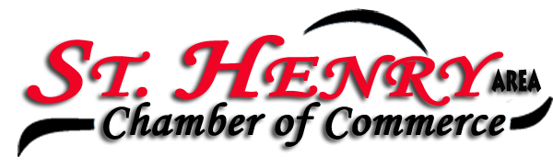
Place: Romers Party Room
Date: 2/06/23

Members present: Michelle Dues, Eydie Kremer, Adam Puthoff, Paul Moorman, Jenn Bruns, Josh Schmackers, Stan Sutter, Frank Urwin, John Yoder, Lori Homan, Kelley Baker, Jackie Muhlenkamp, Dylan Graham, Pam and Mike Fishbaugh

President Michelle Dues called the meeting to order.

Minutes from the January meeting were approved by Kelley and seconded by Josh.

No treasures report.

Adam Puthoff, Paul Moorman and Jenn Bruns from the SH School district spoke about the March renewal levy, election is March 19th. Paul is a member of the SH school board; current president is Andy Fullenkamp. SH school district has the lowest millage in the county, the leaders have been very cost conscious on how the money is being used. The money collected thru the emergency levy will be used for building maintenance, teacher’s salaries (over 85% of the total budget is used for teacher salaries and benefits). The levy accounts for 25% of the total tax revenue. Jenn shared how the real estate tax impacts the school district, which allows the emergency levy to not be larger. SH is only local school district without a local income tax, we also have no facility or bond debt.

Paul shared Karl Gast has retired from Beckman and Gast, his last day was Friday! Paul is the operation manager and our newest Chamber member. Beckman Gast has 13 full time employees and are looking to hire. He stated the learning curve is five to ten years in the canning industry.

The banquet will be April 22nd at Mercer County Elks. We will again sell tables for sponsorship. The entertainment will be trivia. More details will be shared in March.

Solar Eclipse is happening on Monday April 8^{th.} Local schools have decided to close. Discussion about local restaurants not being open on Monday’s and the influx of people that will be in our area. Traffic will be a major concern for shift changes for local factories. Dr. Fishbaugh cautioned all to be careful when viewing the eclipse and wearing the correct eyewear.

SOCA has been renewed for the Chamber.

Chamber banner to be purchased from Homestretch.

St Paddy parade March 17th.

Kelley won the Pot of Gold - $22 Total

Kelley motioned to adjourn, and Frank seconded it.

Businesses/Organizations represented at the Chamber meeting were:

Beckman and Gast
Cooper Farms
Edward Jones
Fishbaugh Family Eye Care
Ohio Indiana Roofing
Peoples Bank
Romers
SH Subway
Stammen Insurance
ventureLinx
Village of SH
Wabash Mutual

Next meeting will be March 5th at Romers at 7:30 a.m. Please note we are going back to our Tuesday morning meetings. Hope to see you there!

Eydie Kremer
Chamber Secretary

