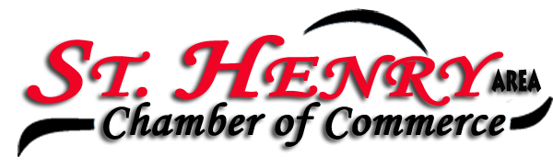
Place: Romers Party Room
Date: 3/05/24

Members present: Michelle Dues, Eydie Kremer, Adam Puthoff, Jenn Bruns, Josh Schmackers, Stan Sutter, Frank Urwin, Lori Homan, Kelley Baker, Jackie Muhlenkamp, Dylan Graham, Karen Romer, Brad Huelsman and David Romer.

President Michelle Dues called the meeting to order.

Minutes from the February meeting were approved by Frank and seconded by Josh.

David shared the treasures report. Dues are coming in nicely, they were due February 15th. He’ll reach out to those members who haven’t yet paid.

Letter for the Chamber banquet will be sent soon. Date is Monday April 22nd at the Elks. Meal provided by Romers. Josh is lining up entertainment.

A letter has been sent re the SH Picnic. This will be held July 5, 6,7 Seeing some response from that communication.

Solar Eclipse is happening on Monday April 8^{th.} Local schools have decided to close. Discussion about local restaurants not being open on Monday’s and the influx of people that will be in our area. Romers will be having a buffet that day. Traffic will be a major concern for shift changes for local factories, however many of the local businesses will be closed.

Chamber banner has been purchased from Homestretch. We’ll use it at the local tournaments and perhaps the SH St Paddy parade. Any takers on wanting to walk with it??

Motion made by Frank to donate to the SH Amphitheater, seconded by Michelle.

Karen won the Pot of Gold - $28 Total

Kelley motioned to adjourn, and Frank seconded it.

Businesses/Organizations represented at the Chamber meeting were:

Cooper Farms
Edward Jones
Ohio Indiana Roofing
Peoples Bank
Rindler Truss
Romers
SH Bank
SH School District
SH Subway
Stammen Insurance
The Gardens of SH
ventureLinx
Village of SH
Wabash Mutual

No meeting in April, please plan to attend the Chamber banquet on April 22nd. Details will be sent under a separate email.

Eydie Kremer
Chamber Secretary

