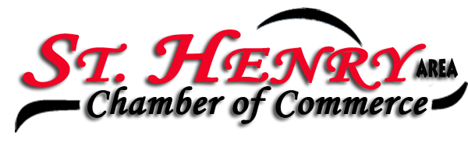
Place: SH EMS
Date: 5/07/24

Members present: Michelle Dues, Eydie Kremer, Adam Puthoff, Lori Homan, Kelley Baker, Jackie Muhlenkamp, Dylan Graham, Edyie Wourms.

President Michelle Dues called the meeting to order.

Minutes from the March meeting were approved by Kelly and seconded by Jackie.

Eydie shared the treasures report that David had emailed. Dues haven’t been received yet from a few members.

SH Picnic will be held July 5th, 6th and 7th. There will be a sign-up sheet sent soon to help man the Chamber booth. Question on Chance board if it needs updated. Kim B usually handles.

Michelle asked for some feedback from the banquet. Everyone seemed to enjoy the trivia contest and the setting.

Chamber banner has been purchased from Homestretch. We’ll use it at the local tournaments and at Hopefest this Friday, providing it’s permitted.

The question was raised if the Chamber should forward information promoting local businesses when it’s sent to the Chamber email. It was decided if they’re a Chamber member that should be one of the benefits.

Discussion about after hours event instead of August meeting. More details as it gets closer. If it happens, we need to line up food, prizes, etc. This will be decided at the June meeting.

Matt Nietfeld won the Pot of Gold - $20 Total. Matt gave a tour of the EMS facility; how fortunate we are to have this in our community. He also offered tours to any businesses that might be interested and also said they’re always looking for volunteers.

Kelley motioned to adjourn, and Adam seconded it.

Businesses/Organizations represented at the Chamber meeting were:

Cooper Farms
Peoples Bank
SH School District
SH Subway
The Gardens of SH
Technical Roofing
Wabash Mutual

Next meeting will be June 4th at Romers.

Eydie Kremer
Chamber Secretary

