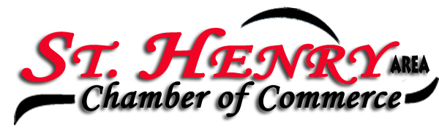
Place: Romers Party Room
Date: 10/01/24

Members present: Eydie Kremer, Michelle Dues, Stan Sutter, Jackie Muhlenkamp, Jodi Ritter, Josh Schmackers, Karen Romer, Deb Mertz, Kelly Baker, David Romer, Joe Brackman, and Jordan Speck

President Michelle Dues called the meeting to order.

Minutes from the September meeting were approved by Kelly and seconded by Stan.

Treasurers report given by David.

Michelle talked about the SOCA luncheon and the benefits offered. PowerPoint presentation was sent to members from the luncheon.

We had twelve members of the community attend the meeting to talk about their organizations as part of the SH Combined drive.

Organizations represented included:

SH Freedom Amphitheater
SH Summer Baseball program
Cancer Association of Mercer County
Sherriff representative for Dare Program
Mercer County Right to Life
Venture Lynx
Southern Mercer County EMS
Everheart Hospice
SH Girl Scouts
Center for Neurological Development
SH Soccer
SH Swim and Dive

All the representatives had insightful information on what services they offer/perform and are extremely grateful to be included on the Combined Drive flyer that will be sent this week. We thanked them for attending and sharing, great opportunity to hear about all the good things happening in our Village and Mercer County.

The SH holiday open house will be November 8th 9th and 10th. Kim would like to remind everyone if you wish to participate in the Holiday Open House she needs to hear from you by Friday. Any donations also need to be finalized by Friday to make the advertising deadlines. Please reach out to Kim with questions.

Our next meeting will be the second Tuesday of November so we can draw the winners from the Holiday open house baskets.

Sue from WCSM said 23 local businesses are participating in a holiday promotion with the station.

Kelly motioned to adjourn, and Josh seconded it.

Businesses/Organizations represented at the Chamber meeting were:

Cooper Farms
Cozy Cabin
Fishbaugh Eye Care
Gardens of SH
Prudential
Romers
Stammen Insurance
SH Bank
Village of SH
Wabash Mutual

Next meeting will be November 12th at Romer’s at 7:30 am.

Eydie Kremer
Chamber Secretary

